Why we need to prioritise technologies in schools.

1. **Australia is lacking in technology**

**Last year it was rank 55 for internet speed behind kazikstan, Latvia and Romania**

1. Australia rates 45th when it comes to digital and technological skills. There’s hardly been silence on this issue: the [Australian Computer Society](https://www.acs.org.au/content/dam/acs/acs-publications/PJ52569-Australias-Digital-Pulse-2016_LAYOUT_Final_Web.pdf), among many others, has long emphasised the growing labour market for IT skills, and the need to enhance training.
2. In education, Australia has a global ranking of 51st, down 20 places since 2013. In my view, this is substantially due to two factors. The first is the telling ranking of 52nd for the pupil-teacher ratio in tertiary education, which raises questions about the adequacy of university funding.
3. **Technology is the key to the future**

* For instance, although Australia is ranked number one in the world for how many years kids typically spend at school, it's a lowly 77th based on how many people are graduating from science and engineering degrees. On that measure, the data puts Australia below Azerbaijan, Mongolia and Guatemala. Data source: [Global Innovation Index 2015](https://www.globalinnovationindex.org/content/page/gii-full-report-2015/)

<https://www.theverge.com/2017/11/30/16719092/automation-robots-jobs-global-800-million-forecast>

A new report predicts that by 2030, as many as 800 million jobs could be lost worldwide to automation. The [study](https://www.mckinsey.com/global-themes/future-of-organizations-and-work/what-the-future-of-work-will-mean-for-jobs-skills-and-wages), compiled by the McKinsey Global Institute, says that advances in AI and robotics will have a drastic effect on everyday working lives, comparable to the shift away from agricultural societies during the Industrial Revolution. In the US alone, between 39 and 73 million jobs stand to be automated — making up around a third of the total workforce.

1. **We already have the infrastructure to start this progression**

In April 2009, nearly a third (31%) of children aged 5-14 years had their own mobile phones (841,000 children), however for older children (aged 12-14 years) this proportion was much higher (76%)

[**http://www.abc.net.au/news/2013-02-02/federal-government-set-to-end-school-laptops-scheme/4497572**](http://www.abc.net.au/news/2013-02-02/federal-government-set-to-end-school-laptops-scheme/4497572)

1. **It helps alleviate the infrastructure of schooling and creates egalitarian opportunities.**

 individualized learning and improved outcomes

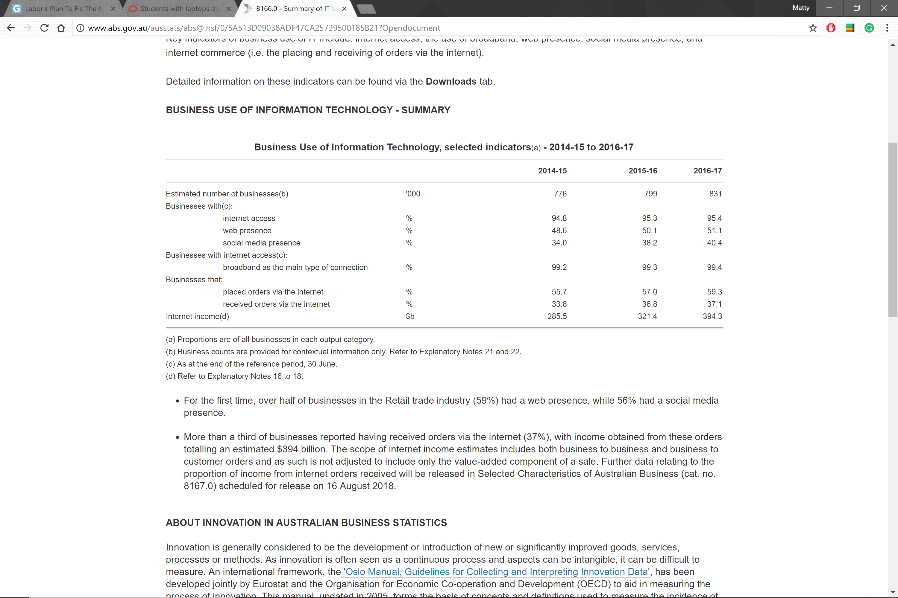

<https://theconversation.com/we-asked-five-experts-should-mobile-phones-be-banned-in-schools-98708>

<https://theconversation.com/students-with-laptops-did-better-in-hsc-science-46326>

<http://theconversation.com/ict-is-failing-in-schools-heres-why-50890>